Chapter 12, Solution 42.

The load determines the power factor.
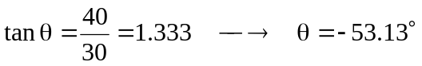

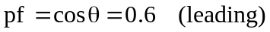

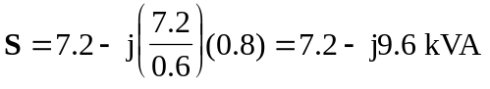
But 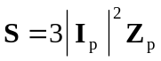

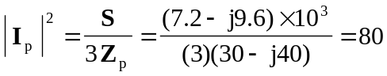

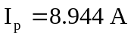

I_{L}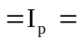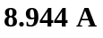

V_{L}